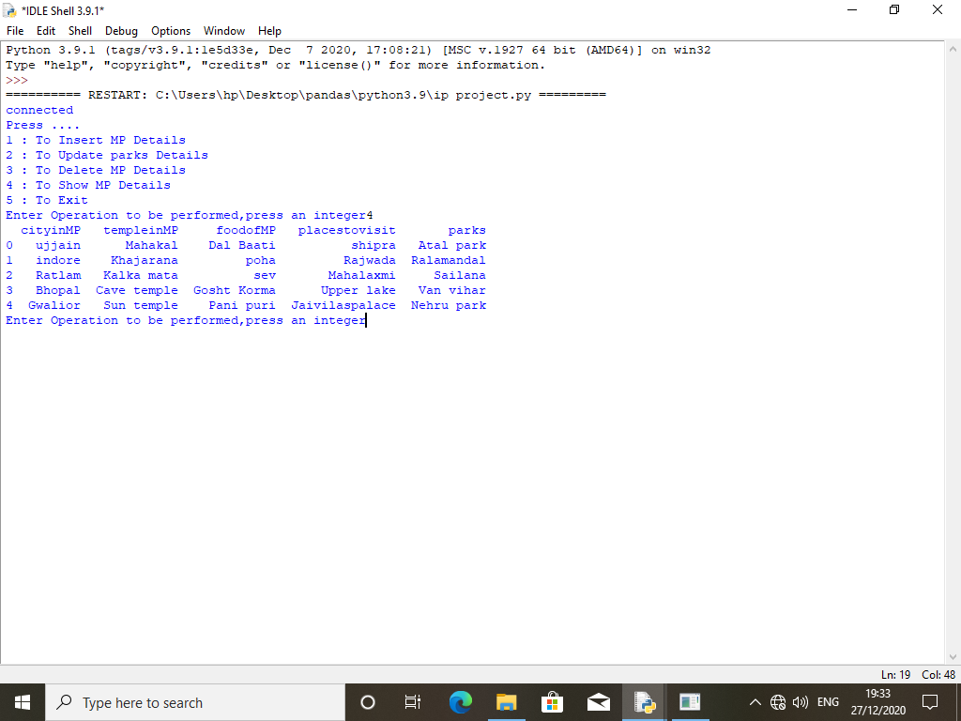

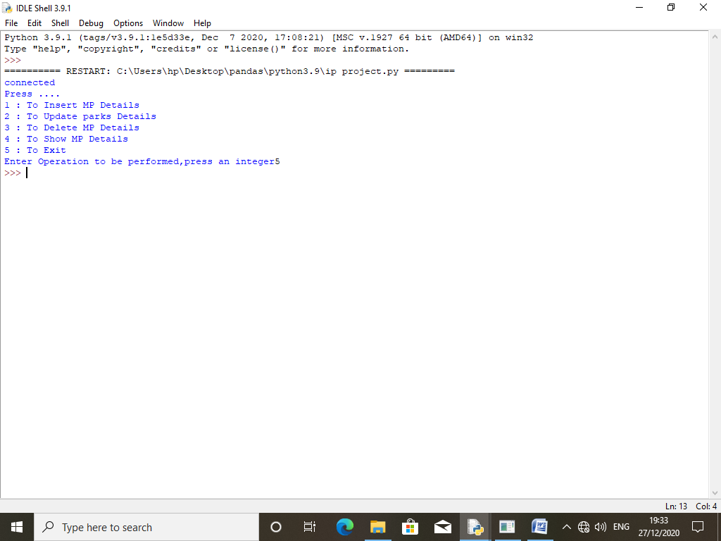

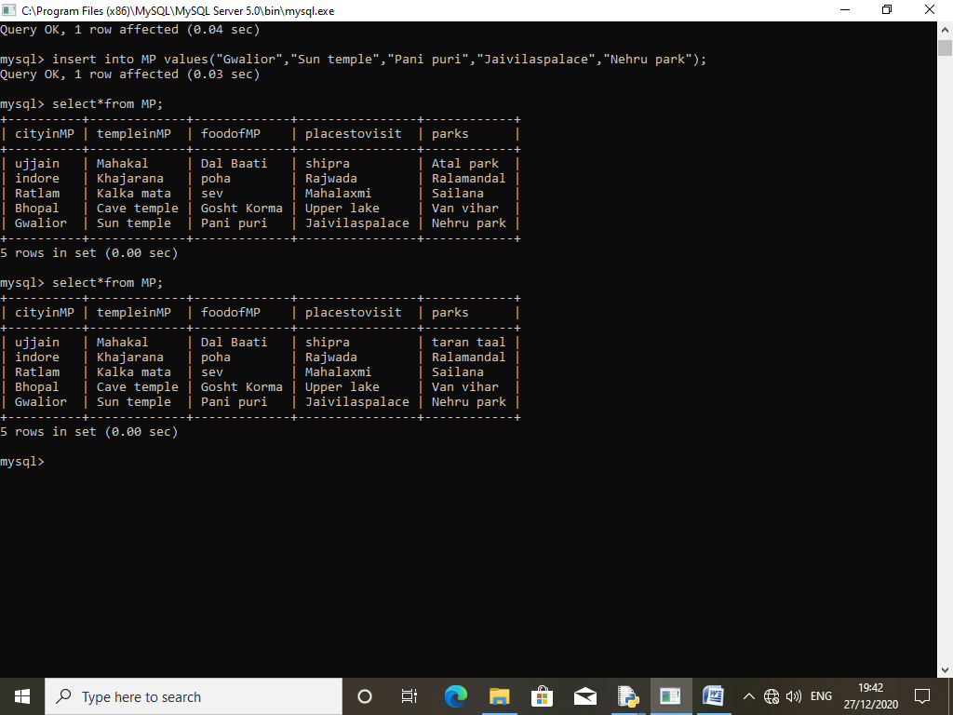

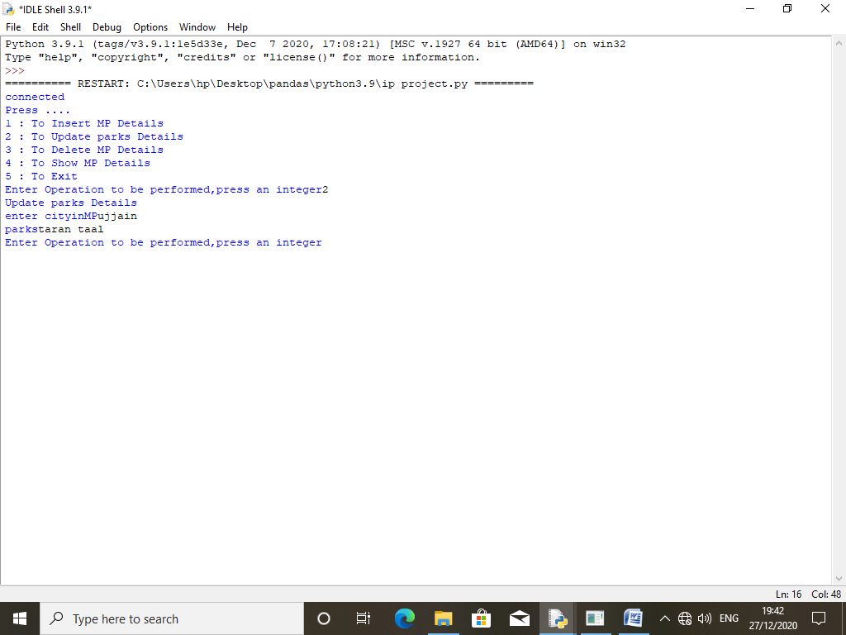

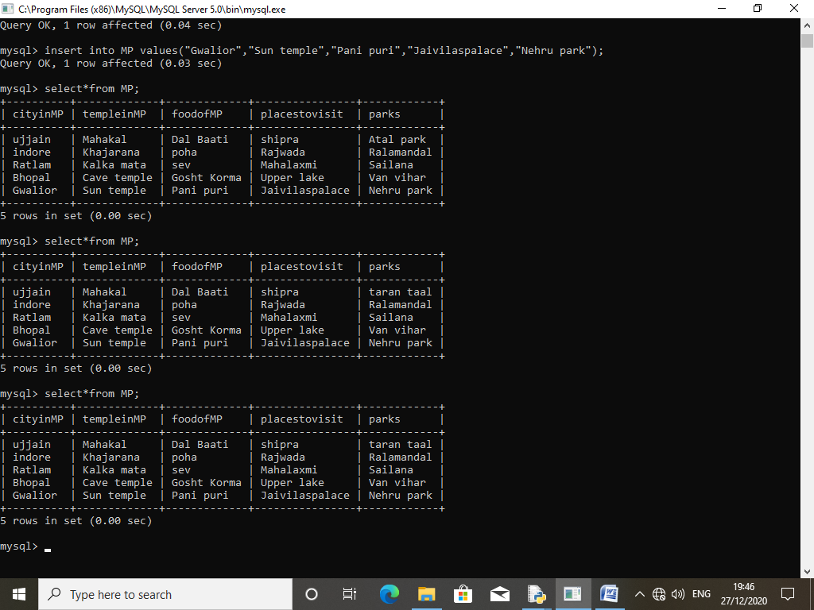

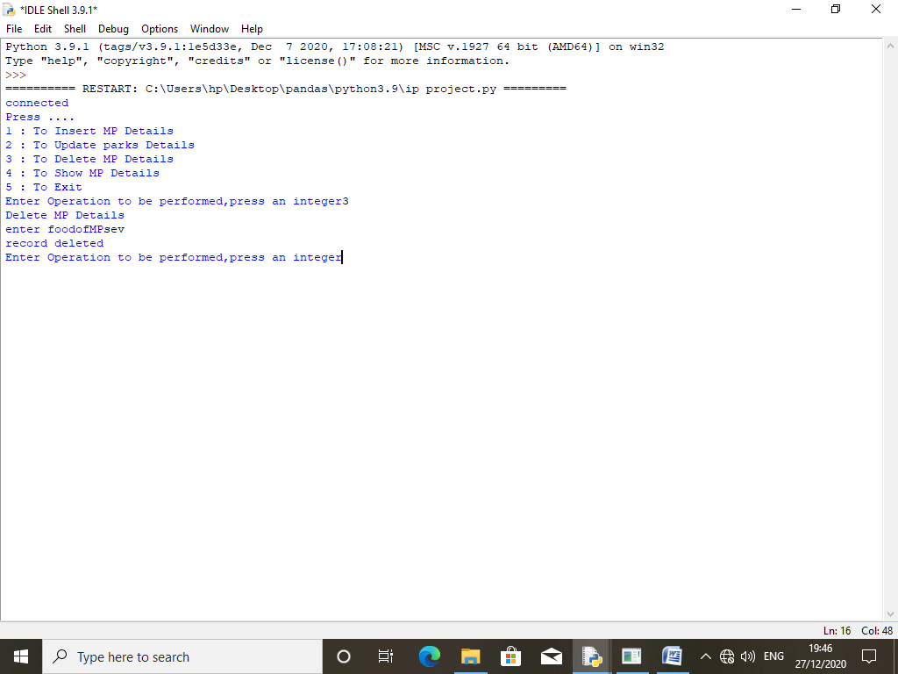

import pandas as pd

import mysql.connector as sq

import sys

#-----------------------------------------------CRUD in Python----------------------------------------

con=sq.connect(host="localhost",user="root",passwd="123",database="project",charset="utf8")

if con.is_connected():

print("connected ")

else:

print("problem in connection")

cur1=con.cursor()

def insert_details():

print("Ineserting details in MP tables")

cityinMP=input("enter cityinMP")

templeinMP=input("enter templeinMP")

foodofMP=input("enter foodofMP")

placestovisit=input("enter placestovisit")

parks=input("enter parks")

sql= ("INSERT INTO INDIA(cityinMP,templeinMP,foodofMP, placestovisit, parks)""VALUES (%s, %s, %s, %s, %s)")

data = (cityinMP,templeinMP,foodofMP, placestovisit, parks)

cur1.execute(sql,data)

con.commit()

print("Data inserted")

def updateparks():

print("Update parks Details")

cityinMP=input("enter cityinMP")

parks=input("parks")

sql = '''update MP set parks=%swhere cityinMP= %s '''

data=(parks,cityinMP)

cur1.execute(sql,data)

con.commit()

#--------------------------------------------------------------------------------------------------------

def foodofMP():

print("Delete MP Details")

foodofMP=input("enter foodofMP")

sql= '''Delete from MP where foodofMP="%s" '''

cur1.execute(sql)

con.commit()

print("record deleted")

def searchbytempleinMP():

templeinMP=input("Enter templeinMP")

sql="select *from MP where templeinMP=%s"%templeinMP

cur1.execute(sql)

con.commit()

print(df)

#--------------------------------------------------------------------------------------------------------

def searchbyplacestovisit():

placestovisit=input("Enter placestovisit ")

s="select *from MP where placestovisit=%s"%placestovisit

df=pd.read_sql(s,con)

print(df)

def searchbycityinMP():

cityinMP=input("enter cityinMP")

s="select *from MP where cityinMP=%s"%cityinMP

df=pd.read_sql(s,con)

print(df)

def showall():

df=pd.read_sql("select*from MP;",con)

print(df)

#--------------------------------------------------------------------------------------------------------

print("Press ....")

print("1 : To Insert MP Details ")

print("2 : To Update parks Details ")

print("3 : To Delete MP Details ")

print("4 : To Show MP Details ")

print("5 : To Exit ")

choice=int(input("Enter Operation to be performed,press an integer"))

while(choice!=5):

if(choice==1):

insert_details()

elif(choice==2):

updateparks()

elif(choice==3):

foodofMP()

elif(choice==4):

showall()

elif(choice==5):

sys.exit()

else:

print("Enter integer between 1-5")

choice=float(input("Enter Operation to be performed,press an integer"))